

230143107014

PATEL BINIT UMESHKUMAR

21/01/2026 28/01/2026
Computer Engineering 8th
FICE Education Pvt. Ltd.
_

Adarsh Gupta

Completed the registration for the Microsoft Elevate Program and attended the orientation session.
Understood the 12-week roadmap, evaluation criteria, and platform usage. Gained clarity on virtual labs, assignment submission process, and mentorship structure provided during the internship.
Attended the session on AI fundamentals covering its definition, history, and types. Learned about Narrow AI, General AI, and Super AI along with real-world applications. Also explored basic AI categories and ethical considerations in AI development.
Learned the complete data analytics lifecycle including data collection, cleaning, analysis, and visualization.
Understood types of analytics such as descriptive, predictive, and prescriptive. Also studied differences between Data Analytics, Data Science, and Business Intelligence.
Analyzed the “Entertainment & Media” problem domain for the project. Identified challenges like large-scale monitoring, delayed detection, and high false alarms. Started exploring possible AI/ML-based solutions to
address these issues.
Set up the development environment by installing Python, VS Code, and Jupyter Notebook. Installed essential libraries like NumPy, Pandas, and Matplotlib. Verified setup by running basic programs for future analytics and ML tasks.
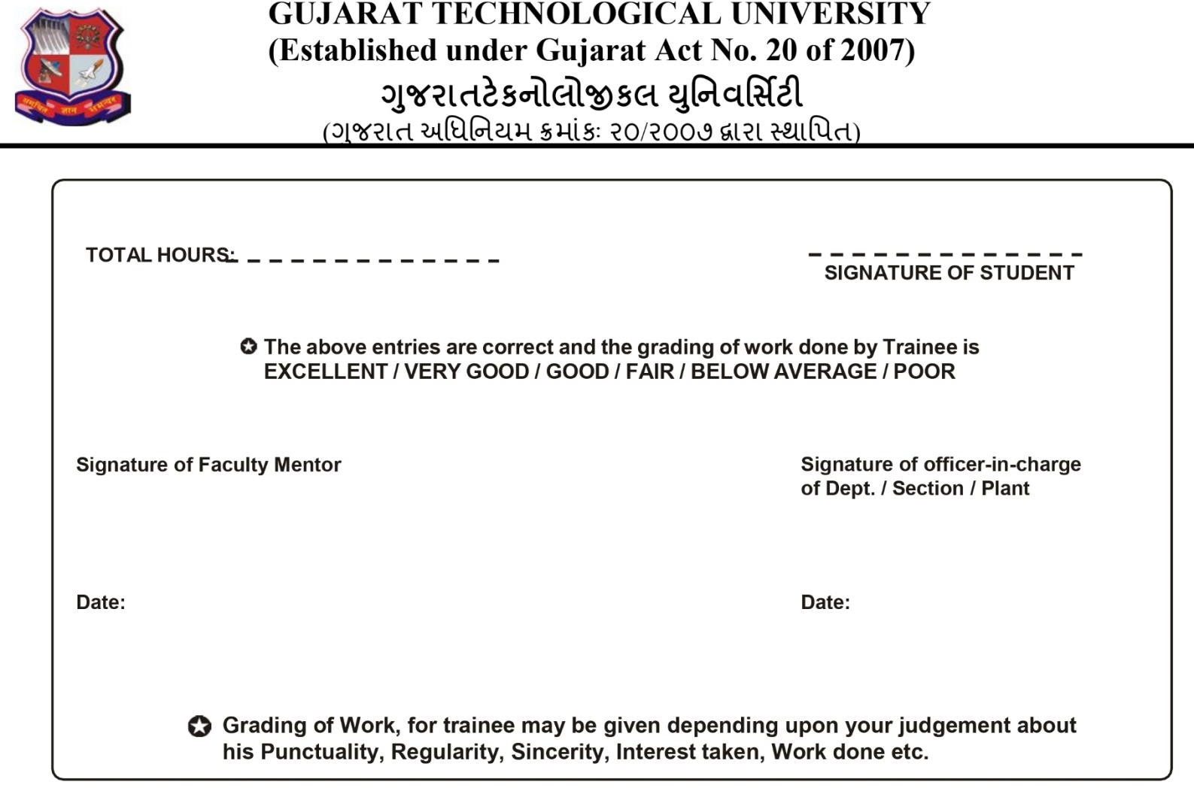

30


230143107014

PATEL BINIT UMESHKUMAR

30/01/2026 04/02/2026
Computer Engineering 8th
FICE Education Pvt. Ltd.
_

Adarsh Gupta

Attended the session on data cleaning techniques for handling real-world datasets. Learned methods to manage missing values, detect outliers using IQR and Z-score, and apply normalization techniques. Also explored encoding methods for categorical data and basic feature engineering concepts.
Participated in the EDA session to understand data patterns and relationships. Learned to use statistical summaries and visualization tools like histograms and box plots. Also explored correlation analysis and techniques to identify trends and insights from datasets.
Learned to create various visualizations such as line plots, bar charts, scatter plots, and heatmaps. Understood how to customize graphs using titles, labels, and legends for better presentation. Gained knowledge on
effectively communicating data insights through visual storytelling.
Focused on finalizing the project “AI-Based Heart Disease Prediction System.” Defined problem statement and objectives based on healthcare challenges. Planned to use Random Forest for prediction and Streamlit for deployment, along with a structured development roadmap.


35


230143107014

PATEL BINIT UMESHKUMAR

06/02/2026 11/02/2026
Computer Engineering 8th
FICE Education Pvt. Ltd.
_

Adarsh Gupta

Learned the fundamentals of DAX including syntax, calculated columns, and measures. Practiced functions like SUM, AVERAGE, and CALCULATE for data analysis. Understood concepts such as filter context and time intelligence functions for dynamic reporting.
Explored different visualization types such as bar charts, line graphs, maps, and tables. Learned how to choose appropriate visuals based on data type. Also practiced formatting and customizing visuals for better data presentation.
Learned to create interactive dashboards using slicers, filters, and drill-through features. Implemented cross- filtering between visuals to enhance user experience. Built dynamic reports enabling better data exploration and storytelling.
Started collecting dataset for the surveillance project using UCF-Crime videos. Analyzed video properties like resolution and duration. Organized dataset structure and documented key characteristics for further
processing.
Practiced video processing using OpenCV, including frame extraction and resizing. Converted video frames into image datasets for model training. Verified extracted frames for quality and suitability for object
detection tasks.
Successfully registered for Azure for Students account and explored the portal. Reviewed services like Blob Storage and Azure Functions for project use. Planned cloud integration for storing and processing
surveillance data.


32


230143107014

PATEL BINIT UMESHKUMAR

13/02/2026 18/02/2026
Computer Engineering 8th
FICE Education Pvt. Ltd.
_

Adarsh Gupta

Learned advanced DAX functions such as SUMX, FILTER, and time intelligence calculations. Practiced creating complex measures like running totals and year-over-year analysis. Focused on optimizing DAX queries for better performance.
Studied dashboard design principles including layout, color usage, and KPI visualization. Created multi-page dashboards with navigation and interactivity. Ensured dashboards were user-friendly and visually effective.
Gained understanding of machine learning concepts including supervised and unsupervised learning. Learned about ML workflow, training data, and evaluation metrics. Explored common algorithms like Linear
Regression and Decision Trees.
Completed a comprehensive Power BI project including data modeling and dashboard creation. Implemented multiple DAX measures and interactive visuals. Submitted the assignment demonstrating practical
understanding of BI concepts.
Participated in peer discussions and doubt-solving sessions. Shared knowledge and resolved issues related to DAX and dashboards. Gained insights through collaborative learning with fellow interns.


30


230143107014

PATEL BINIT UMESHKUMAR

20/02/2026 25/02/2026
Computer Engineering 8th
FICE Education Pvt. Ltd.
_

Adarsh Gupta

Learned the fundamentals of supervised learning using labeled datasets. Implemented algorithms like Linear Regression, Logistic Regression, Decision Trees, and Random Forest. Practiced model training, evaluation, and techniques like train-test split and cross-validation.
Explored unsupervised learning techniques for analyzing unlabeled data. Implemented clustering algorithms such as K-Means and studied dimensionality reduction using PCA. Understood applications like customer segmentation and anomaly detection.
Gained basic understanding of reinforcement learning concepts including agents, environments, and rewards. Learned about Q-learning and the exploration vs exploitation trade-off. Explored real-world applications such as robotics and game-based learning systems.
Completed a comprehensive assignment covering regression, classification, and clustering tasks.
Implemented multiple models and compared their performance using evaluation metrics. Documented the complete workflow in a Jupyter Notebook.
Worked extensively with the scikit-learn library for data preprocessing and model building. Practiced using pipelines, feature scaling, and evaluation functions. Strengthened practical understanding of ML workflows for project implementation.


34


230143107014

PATEL BINIT UMESHKUMAR

27/02/2026 02/03/2026
Computer Engineering 8th
FICE Education Pvt. Ltd.
_

Adarsh Gupta

Learned the core concepts of deep learning including neural networks and their working. Understood forward propagation, backpropagation, and loss functions. Explored how deep learning is applied in image and pattern recognition tasks.
Built and trained neural network models using TensorFlow and Keras. Learned about layers, activation
functions, and optimizers. Implemented models on datasets like MNIST and evaluated their performance.
Configured the development environment by installing TensorFlow, Keras, and supporting libraries. Explored GPU acceleration using local setup and Google Colab. Verified the setup by running sample neural network models.
Gained initial understanding of Convolutional Neural Networks and their importance in image processing. Learned about convolution, pooling, and feature extraction. Connected these concepts to object detection tasks required in the project.
Completed assignment involving ANN model development and evaluation. Implemented different
architectures and compared performance using various optimizers. Visualized training results using accuracy and loss graphs.


36


230143107014

PATEL BINIT UMESHKUMAR

06/03/2026 11/03/2026
Computer Engineering 8th
FICE Education Pvt. Ltd.
_

Adarsh Gupta

Learned advanced concepts like transfer learning and model optimization. Used pre-trained models such as VGG16 for feature extraction and fine-tuning. Practiced data augmentation and monitored training using TensorBoard.
Explored fundamentals of Generative AI including GANs, VAEs, and diffusion models. Understood
differences between generative and discriminative models. Studied applications like text, image, and code generation along with ethical considerations.
Built Convolutional Neural Network (CNN) models for image classification tasks. Applied multiple
convolution and pooling layers with data augmentation. Analyzed model performance and improved accuracy through tuning.
Completed assignment covering CNN implementation and transfer learning. Compared model performance and applied optimization techniques. Submitted detailed notebook with results and analysis.


38


230143107014

PATEL BINIT UMESHKUMAR

13/03/2026 18/03/2026
Computer Engineering 8th
FICE Education Pvt. Ltd.
_

Adarsh Gupta

Learned to use AI coding assistants like GitHub Copilot for faster development. Practiced generating code, documentation, and unit tests using prompts. Understood advantages and limitations of AI-assisted
programming.
Studied cloud computing concepts including IaaS, PaaS, and SaaS models. Learned about cloud architecture, scalability, and deployment models. Understood benefits of cloud in AI/ML applications.
Explored Azure platform, its services, and global infrastructure. Learned about resource groups, storage services, and compute options. Understood how Azure supports scalable AI-based systems.
Configured Azure for Students account and explored available services. Organized project dataset into structured directories for further processing. Planned cloud integration for storage and computation.
Completed assignments on AI coding tools, cloud architecture, and Azure services. Designed system
architectures and implemented practical tasks. Strengthened understanding through hands-on exercises.
Participated in peer discussions and resolved doubts related to cloud and AI concepts. Shared insights on Azure services and project implementation strategies. Improved understanding through collaborative learning.


34


230143107014

PATEL BINIT UMESHKUMAR

20/03/2026 25/03/2026
Computer Engineering 8th
FICE Education Pvt. Ltd.
_

Adarsh Gupta

Learned Azure Blob Storage architecture including storage accounts, containers, and blobs. Performed operations like uploading, downloading, and managing files. Practiced using Python SDK to automate storage tasks and implemented backup solutions.
Explored serverless computing using Azure Functions with different triggers like HTTP, Timer, and Blob. Developed functions for processing data and automating workflows. Understood event-driven architecture and deployment using Azure portal and VS Code.
Learned about NoSQL databases using Azure Cosmos DB and its document-based structure. Practiced CRUD operations using Python SDK and SQL queries. Understood partitioning, scalability, and performance optimization techniques.
Practiced managing Azure resources using Azure CLI and PowerShell. Automated tasks like resource creation, storage management, and deployment. Learned scripting techniques for efficient cloud operations.
Started preparing for Azure Fundamentals certification by studying cloud concepts and Azure services. Completed learning modules and practiced sample questions. Strengthened theoretical understanding of cloud computing.


36


230143107014

PATEL BINIT UMESHKUMAR

27/03/2026 01/04/2026
Computer Engineering 8th
FICE Education Pvt. Ltd.
_

Adarsh Gupta

Learned DevOps concepts including continuous integration and continuous deployment. Explored Azure DevOps tools like Repos, Pipelines, and Boards. Understood how automation improves development and deployment workflows.
Studied the process of building automated pipelines for code integration and deployment. Learned steps such as build, test, and release stages. Understood how pipelines ensure faster and error-free software delivery.
Explored tools used in DevOps practices and their role in collaboration. Understood version control, issue tracking, and continuous monitoring. Learned how teams manage projects efficiently using DevOps
methodologies.
Focused on integrating different modules of the project including ML models and cloud services. Reviewed system workflow and prepared for final implementation. Ensured proper alignment between development and deployment stages.
Continued practicing Azure services and reviewed previously learned concepts. Strengthened understanding of cloud-based deployments. Prepared for applying these services in the final project phase.
Updated project documentation with current progress and architecture details. Reviewed learning outcomes from previous weeks. Prepared for final stages of project development and presentation.


38


230143107014

PATEL BINIT UMESHKUMAR

03/04/2026 08/04/2026
Computer Engineering 8th
FICE Education Pvt. Ltd.
_

Adarsh Gupta

Started integrating all major components of the project including the dataset, machine learning model, and Streamlit web application. Worked on connecting data preprocessing, model prediction, and user interface modules. Ensured smooth data flow from user input to prediction output.
Tested the trained models using validation data and analyzed performance metrics such as accuracy and confusion matrix. Identified issues in prediction performance and improved accuracy by tuning model parameters and selecting the best algorithm (Random Forest).
Deployed the project using Streamlit for web-based access. Configured the application environment and
ensured proper functioning of the model in a live setting. Verified that the system runs efficiently and handles user inputs correctly.
Worked on generating visualizations such as confusion matrix, accuracy graph, and feature importance graph. These visual tools help in understanding model performance and improving interpretability of results.
Updated project documentation including system architecture, methodology, implementation details, and
results. Organized code files, dataset, and report for final submission. Ensured clarity and proper formatting of all technical content.
Prepared final presentation slides covering project overview, problem statement, methodology,
implementation, and results. Structured the content to clearly explain the workflow and practiced presenting the project confidently for viva.


40


230143107014

PATEL BINIT UMESHKUMAR

10/04/2026 15/04/2026
Computer Engineering 8th
FICE Education Pvt. Ltd.
_

Adarsh Gupta

Completed all remaining project components and ensured full system functionality. Verified integration of AI model, dataset, and cloud services. Conducted final testing to confirm expected outputs.
Performed end-to-end testing of the disease risk prediction system. Validated model predictions and system responses. Ensured reliability and consistency in real-time detection scenarios.
Prepared and finalized the internship report with all weekly activities and project details. Included methodology, results, and learning outcomes. Ensured proper formatting as per submission guidelines.
Delivered the final project presentation summarizing work done during the internship. Explained system architecture, technologies used, and results achieved. Successfully submitted all required documents and project files.
Reviewed all concepts learned throughout the internship including AI, ML, Deep Learning, and Cloud Computing. Identified key skills developed during the program. Reflected on practical exposure gained.
Successfully completed the internship with a strong understanding of real-world AI/ML applications. Gained hands-on experience in project development and cloud deployment. Concluded the internship with valuable technical and professional knowledge.


35

